PROJECT PROPOSAL

BUSINESS INTELLIGENCE SYSTEM

Project Specification prepared by

**ULLAS UMESH (N1221317)**

2917 words



**Contents**

Introduction................................................................................................................................3

1. Overview of AkzoNobel................................................................................................3
2. Scope of the System.......................................................................................................3
3. Mission and Vision of AkzoNobel.................................................................................4

Departmental Objective..............................................................................................................4

1. Supply Chain and Procurement......................................................................................4
2. Production......................................................................................................................4
3. Research and Development............................................................................................5
4. Sustainability and Corporate Responsibility..................................................................5
5. Relationship between Strategy, KPI’s, Roles and MBO’s.............................................5

Requirements Gathering ............................................................................................................6

Business Intelligence System Design.........................................................................................7

1. Data Collection, Transformation and Storage................................................................7
2. Analytics Models............................................................................................................7
3. Dashboard Development................................................................................................8

Project Methodology .................................................................................................................9

Metrics Dimensions & Derivation............................................................................................10

1. Supply Chain and Procurement.....................................................................................10
2. Production....................................................................................................................11
3. Research and Development..........................................................................................12
4. Sustainability and Corporate Responsibility.................................................................13

Dashboard Design ....................................................................................................................15

1. Supply Chain and Procurement.....................................................................................15
2. Production....................................................................................................................21
3. Research and Development..........................................................................................27
4. Sustainability and Corporate Responsibility.................................................................32

Conclusion……………………………………………………………………………………36

Reference……………………………………………………………………………………37

**Introduction**

**1. Overview of AkzoNobel**

AkzoNobel, a global leader in paints, coatings, and specialty chemicals since 1646, is recognized for its commitment to innovation, sustainability, and excellence. Operating in the dynamic paints, coatings, and specialty chemicals sector, AkzoNobel faces challenges related to market trends and regulatory landscapes. AkzoNobel’s impact is truly global, with a presence in over 150 countries. This expensive reach allows the company to cater to diverse markets, adapting its strategies to meet the unique challenges and opportunities present in different regions. Strategic decision-making is essential to address these challenges while adhering to sustainability principles. A standout feature of the organization is the strong commitment to sustainability. The company actively addresses environmental concerns, setting and achieving targets to reduce its ecological footprint. In this report, we will delve into how AkzoNobel navigates the complex business environment, emphasizing strategic decision-making and sustainability efforts.

Figure 1: Logo of AkzoNobel

**2. Scope of the System**

Our objective is to provide AkzoNobel's senior executives with a comprehensive business analytics system that elevates decision making by delving into data analytics, enabling actionable insights across all facets of the business with a keen focus on sustainability. By providing in-depth insights, the system aims to play a pivotal role in boosting the company’s supply chain management, production, and overall revenue. The analytics system doesn’t just stop at financial gains; it is intricately woven with AkzoNobel’s commitment to sustainability. By harnessing the power of data, the system is poised to contribute to the company’s sustainability objectives while ensuring that every decision made is not just profitable but also aligns with environmental and social responsibility. As concluded by Jacqueline Cramer, it is not possible to evaluate the increases in eco-efficiency brought about by improved products using a single indicator. Utilizing both quantitative and qualitative ecological and economic indicators might help provide a clear picture of the desired outcomes (Cramer and van Lochem 2001). The system is meticulously designed to address specific challenges unique to AkzoNobel, fostering informed and sustainable decision-making.

**3. Mission and Vision of AkzoNobel**

Mission Statement:

"AkzoNobel is committed to creating everyday essentials that make people's lives more liveable and inspiring. Our solutions in paints, coatings, and specialty chemicals contribute to a sustainable future." (AkzoNobel 2024)

Vision Statement:

"We aspire to be the first choice for customers, employees, and partners, leading in innovation, sustainability, and performance. Our goal is to set new standards, driving positive change globally." (AkzoNobel 2024)

**Departmental Objectives**

The scope of our analytics system spans key operational areas, including R&D, supply chain, production, and sustainability initiatives. By seamlessly integrating data sources and providing a unified interface, the system aims to facilitate a holistic view for executives, ensuring that sustainability metrics are seamlessly integrated into decision-making processes (Hristov and Chirico 2019).

**1. Supply Chain and Procurement:**

* Implement sustainable procurement practices to reduce costs and enhance financial efficiency.
* Improve supplier sustainability practices for ethical sourcing and environmental responsibility (Siems, Seuring and Schilling 2022).
* Increase the proportion of suppliers adhering to sustainable and ethical practices.
* Introduce measures to reduce carbon emissions in transportation for environmental sustainability.

**2. Production:**

* Streamline production processes to maximize efficiency and minimize operational costs.
* Launch new product lines through innovative manufacturing processes for revenue growth.
* Implement energy-efficient technologies to minimize energy consumption during production.
* Develop strategies to enhance waste recycling rates and promote sustainable waste management (Akenji and Bengtsson 2014).

**3. Research and Development (R&D):**

* Develop and market products with sustainable features to create new revenue streams.
* Explore opportunities for licensing sustainable technology patents to maximize revenue.
* Increase the adoption of sustainable materials in product development through R&D efforts.
* Improve the environmental impact assessment scores of products throughout their life cycle.

**4. Sustainability and Corporate Responsibility:**

* Evaluate and measure the impact of CSR initiatives on brand equity and customer loyalty.
* Monitor and track revenue attributed to products linked to CSR efforts.
* Assess the positive impact of corporate initiatives on local communities.
* Continuously monitor and maintain high levels of environmental compliance to meet regulatory standards (Hristov and Chirico 2019).

**Relationship between Strategy, KPI’s, Roles and MBO’s**

The relationship with the Departmental objectives and KPIs and how it aligns with the Roles and their MBO’s are clearly mentioned in the below given table.

Table : Relationship between Department, KPIs, Roles and MBOs

**Requirement gathering**

Supply Chain, Production, R&D, Sustainability, and Safety are the departments that we identify as stakeholders for our BI system. Then we begin the process of gathering information in accordance with AkzoNobel's objectives from all these departments. Engagement is at the heart of our approach. We initiate meaningful conversations with stakeholders from each department. We hope to understand the details of their activities, difficulties, and goals via these talks. Active participation guarantees that our BI system is a customised tool developed in partnership with those who have the greatest understanding of the specifics of their department, rather than a one-size-fits-all approach. Understanding the specific needs of each department requires detailed documentation (Kujala, et al. 2022). We capture every detail, from specific requirements and preferences to the key performance indicators (KPIs) that matter most to stakeholders. This documentation serves as the groundwork for a BI system that is finely tuned to the distinct demands of each department chosen within AkzoNobel.

What sets our strategy apart is our commitment to going beyond conventional metrics. Instead of confining ourselves to standard sales and financial indicators, our dashboards are designed to be holistic (Simmers and Haub 2004). They carefully include safety and environmental considerations into every department. By visually representing sustainability and safety metrics, our dashboards become a powerful tool for showcasing AkzoNobel's commitment to responsible business practices.

**Business Intelligence System Design**

**1. Data Collection, Transformation and Storage:**

To start with the BI system design, it is important to integrate data from diverse sources. This includes leveraging AkzoNobel's global operational databases, market data, and dedicated sustainability metrics databases. By consolidating these sources, the BI system can offer a comprehensive view of AkzoNobel's operations.

Ensuring the quality and reliability of the data is crucial. The design incorporates robust Extract, Transform, Load (ETL) processes to clean and transform raw data into a consistent and usable format. In this project we will be carrying out cleaning and transformation separately as this is more efficient compared to traditional ETL (Pan, Zhang and Qin ). This aligns with AkzoNobel's commitment to excellence and ensures that decision-makers have accurate and trustworthy data at their disposal.

**2. Analytics Models:**

Harnessing the power data, different analytics models are integrated into the system. These models support strategic decision-making by providing insights into future trends and align with AkzoNobel's commitment to innovation (Balali, et al. 2020).

1. **Descriptive Analytics:**

To enhance AkzoNobel's understanding of existing data, descriptive analytics is integrated into the BI system. Leveraging advanced business intelligence tools, this component summarizes and describes the historical data comprehensively (Delen and Ram 2018). By using visualization techniques and analytics tools, senior executives gain a clearer understanding of past trends, facilitating more informed decision-making.

1. **Diagnostic Analytics:**

The BI system places a strong emphasis on diagnostic analytics, delving into past performance data to discern patterns and understand the underlying causes of specific outcomes. Analytic dashboards are meticulously designed to present diagnostic insights clearly (Wolniak and Grebski 2023). This component aids senior executives in identifying key factors that have influenced historical performance, enabling them to make data-driven decisions based on a deeper understanding of past events.

1. **Predictive Analytics:**

In line with AkzoNobel's commitment to innovation, predictive analytics takes centre stage in the BI system (Delen and Ram 2018). By utilizing advanced statistical models and machine learning techniques, the system predicts possible future outcomes based on historical and current data trends. This forward-looking approach empowers senior executives to anticipate market trends, optimize strategies, and proactively respond to potential challenges, contributing to the company's competitive edge.

1. **Prescriptive Analytics:**

To provide actionable recommendations, the BI system incorporates prescriptive analytics. This advanced form of predictive analytics not only forecasts possible outcomes but also recommends specific courses of action based on the analyzed data. Senior executives can rely on these recommendations to make strategic decisions aligned with AkzoNobel's objectives (Delen and Ram 2018). This proactive approach ensures that the company stays ahead of the curve by implementing data-driven strategies for sustainable growth.

**3. Dashboard Development:**

The BI system introduces comprehensive dashboards tailored for each department—Supply Chain, Production, R&D, and Sustainability. These dashboards provide senior executives with a unified interface, offering a holistic view of relevant KPIs and metrics. At every level of the BI system, sustainability metrics are seamlessly integrated. This ensures that decisions made by senior executives align with AkzoNobel's commitment to sustainable practices and environmental responsibility.

The BI system is designed with intuitive drill-down paths and wireframe diagrams, enhancing user accessibility. This user-friendly approach empowers senior executives to delve into detailed analytics effortlessly, promoting informed decision-making.

Figure : Represents CRISP-DM methodology

**Project Methodology**

In implementing the comprehensive Business Intelligence (BI) system for AkzoNobel, a systematic and structured project methodology will be employed to ensure the success of this complex initiative. The project will follow a phased approach, beginning with a thorough analysis and understanding of AkzoNobel's specific requirements and objectives. This initial phase will involve close collaboration with key stakeholders across departments, including Supply Chain and Procurement, Production, R&D, and Sustainability and Corporate Responsibility. Following the analysis, the design phase will commence, outlining the system's architecture, data sources, and analytical tools (Anandarajan and Harrison 2019). Development and testing will ensue, ensuring that the BI system aligns seamlessly with AkzoNobel's mission, vision, and goals. Throughout the process, regular communication and feedback loops will be established to address any evolving needs or challenges. The implementation phase will be meticulously planned, considering the unique characteristics of each department, and will involve comprehensive training sessions for end-users. Post-implementation, ongoing support and maintenance will be integral to ensure the system's continuous alignment with AkzoNobel's evolving business landscape (Ivanov and Zlatev 2017). This methodology, combining thorough analysis, strategic design, collaborative development, and responsive implementation, aims to deliver a robust BI system that not only meets the immediate needs of senior executives but also remains adaptable for future challenges and opportunities.



Figure : Project Timetable

**Metrics Dimensions and Derivations**

**1.Supply Chain and Procurement**

Table : Supply chain and Procurement - Metrics Explanation

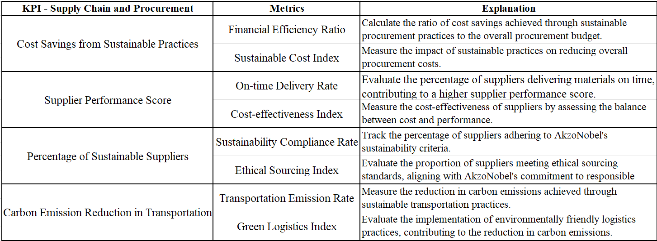

**Metrics Derivation**

Table : Supply chain and Procurement - Metrics Calculation

**2. Production**

Table : Production - Metrics Explanation

**Metrics Derivation**

Table : Production - Metrics Calculation

**3. Research and Development**

Table : R&D - Metrics Explanation

**Metrics Derivation**

Table : R&D - Metrics Calculation

**4.Sustainability and Corporate Responsibility**

Table : Sustainability & CR - Metrics Explanation

**Metrics Derivation**

Table : Metrics Calculation

In summary, the metrics calculations across Supply Chain and Procurement, Production, Research and Development (R&D), and Sustainability and Corporate Responsibility offer a better view of AkzoNobel's performance. From financial efficiency and ethical sourcing to energy consumption reduction and environmental impact assessment, these metrics serve as critical indicators for informed decision-making (Maté, Trujillo and Mylopoulos 2017).

**Dashboard Design**

**1.Supply Chain and Procurement**

The Sustainable Supply Chain Analytics dashboard provides comprehensive insights into AkzoNobel's supply chain and procurement performance, emphasizing sustainability metrics aligned with the company's mission and vision. The dashboard is designed to empower decision-makers with real-time data to enhance efficiency, reduce costs, and promote ethical and sustainable practices throughout the supply chain.

The Sustainable Supply Chain Analytics dashboard empowers AkzoNobel's supply chain and procurement teams to make informed decisions aligned with the company's sustainability goals. It facilitates strategic supplier management, highlights areas for improvement, and supports data-driven initiatives for a more sustainable and efficient supply chain. The user-friendly interface and interactive visualizations ensure that stakeholders can easily navigate and derive actionable insights from the data (Yap 2020).

**Chart Elements and Drill down**

- The dashboard has a set of options where in the user is allowed to change date, month, and year to get insights on not just present data but also the historic data.

- The dashboard has an audio playback option which explains the user about the insights of the dashboard. This makes the dashboard more versatile in terms of user friendliness.

- The main page of the dashboard also has an option to change the region. This enables users to check for information related to a particular region.

- The whole dashboard or a single chart can be exported into CSV, JPG and PDF format for the purpose of report generation.

Figure : Supply chain and Procurement Dashboard Wireframe

Table : Metrics Dimensions

Figure : Financial Efficiency

Figure : % Sustainability

Figure : Cost Savings

Figure : CO2 Emission

Figure : Heat Map

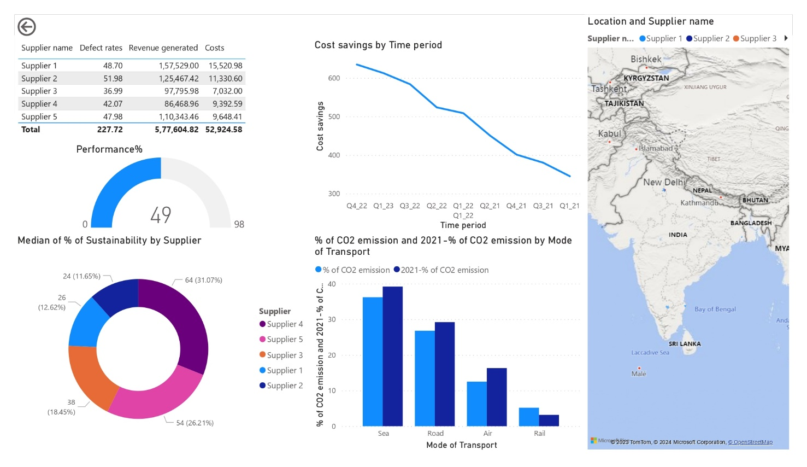

Figure : Supply Chain and Procurement Dashboard

**2. Production**

The Sustainable Production Performance Dashboard is a dynamic tool designed to provide AkzoNobel's decision-makers with real-time insights into the production processes, focusing on efficiency, innovation, and sustainability. This comprehensive dashboard empowers users to monitor KPIs that align with the company's mission and vision, fostering environmentally friendly and cost-effective production practices.

The Sustainable Production Performance Dashboard enables AkzoNobel's production teams to make data-driven decisions that align with the company's commitment to sustainability and innovation. By providing insights into efficiency, revenue generation, energy consumption, and waste recycling, the dashboard empowers users to optimize production processes, reduce environmental impact, and contribute to the company's overarching goals. The interactive and intuitive interface ensures that stakeholders can easily navigate and derive actionable insights from the data (Yap 2020).

**Chart Elements and Drill down**

- The dashboard has a set of options where in the user is allowed to change date, month, and year to get insights on not just present data but also the historic data.

- The dashboard has an audio playback option which explains the user about the insights of the dashboard. This makes the dashboard more versatile in terms of user friendliness.

- The main page of the dashboard also has an option to change the production line. This enables users to check for information related to a particular production line in the plant.

- The whole dashboard or a single chart can be exported into CSV, JPG and PDF format for the purpose of report generation.

Figure : Production Dashboard Wireframe

Table : Metric Dimensions

Figure : Production Efficiency

Figure : Revenue from New products

Figure : % Recyclable Products

Figure : Sustainability Score

Figure : Revenue

Figure : Sustainability factors

Figure : Production Dashboard

**3. Research & Development**

The Sustainable R&D Innovation Dashboard is a strategic tool tailored to provide AkzoNobel's Research and Development (R&D) teams with insights into the sustainability performance of ongoing projects and innovations. This dashboard aligns with the company's mission and vision by focusing on revenue generation from sustainable products, patent licensing, adoption of sustainable materials, and environmental impact assessment scores.

The Sustainable R&D Innovation Dashboard empowers AkzoNobel's R&D teams to make informed decisions that contribute to the company's sustainability objectives. By providing insights into revenue generation, patent licensing, material adoption, and environmental impact assessment, the dashboard supports strategic planning and resource allocation. The user-friendly interface ensures that stakeholders can easily navigate the dashboard, fostering collaboration and data-driven decision-making within the R&D department (Yap 2020).

**Chart Elements and Drill down**

- The dashboard has a set of options where in the user is allowed to change date, month, and year to get insights on not just present data but also the historic data.

- The dashboard has an audio playback option which explains the user about the insights of the dashboard. This makes the dashboard more versatile in terms of user friendliness.

- The main page of the dashboard also has an option to change the R&D Departments. This enables users to check for information related to a particular Department.

- The whole dashboard or a single chart can be exported into CSV, JPG and PDF format for the purpose of report generation.

Figure : R&D Dashboard Wireframe

Table : Metric Dimensions

Figure : Revenue

Figure : Revenue by Sustainable products

Figure : Sustainability Index

Figure : New products

Figure : Licensing profit

Figure : R&D Dashboard

**4. Sustainability and Corporate Responsibility**

The Sustainability and Corporate Responsibility Analytics Dashboard is designed to provide AkzoNobel's leadership with a comprehensive overview of the company's initiatives and performance in the realms of sustainability and corporate responsibility. This dashboard aligns with the organization's mission and vision by focusing on key indicators such as CSR impact on brand equity, revenue from CSR-linked products, community impact index, and environmental compliance rate.

The Sustainability and Corporate Responsibility Analytics Dashboard serves as a strategic tool for AkzoNobel's leadership to monitor and evaluate the impact of corporate responsibility initiatives. By providing clear visualizations of key metrics, the dashboard facilitates data-driven decision-making and enables leaders to steer the company towards greater sustainability and social responsibility. The drill-down options offer detailed insights into specific aspects, fostering a deeper understanding of the organization's contributions to both the environment and society (Yap 2020).

**Chart Elements and Drill down**

- The dashboard has a set of options where in the user is allowed to change date, month, and year to get insights on not just present data but also the historic data.

- The dashboard has an audio playback option which explains the user about the insights of the dashboard. This makes the dashboard more versatile in terms of user friendliness.

- The main page of the dashboard also has an option to change the region. This enables users to check for information related to a particular region.

- The whole dashboard or a single chart can be exported into CSV, JPG and PDF format for the purpose of report generation.

Figure : Sustainability Dashboard wireframe

Table : Metric Dimensions

Figure : CSR Impact

Figure : Units Sold

Figure : Community Impact

Figure : Environmental compliance

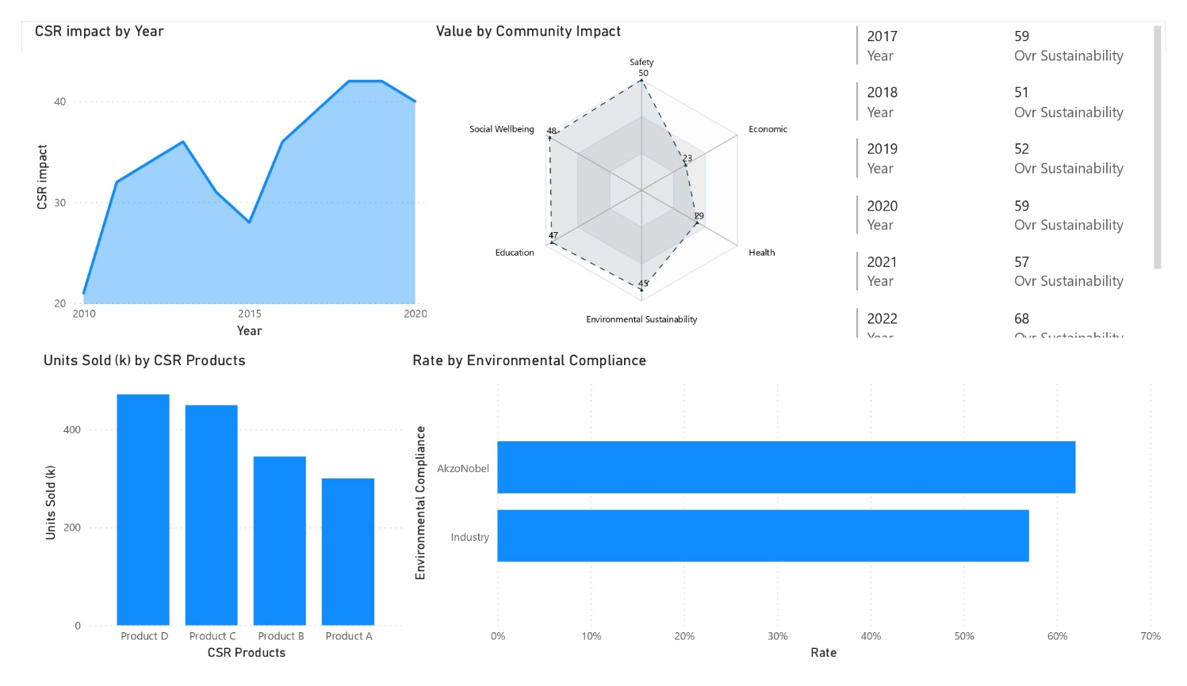

Figure : Sustainability Dashboard

**Conclusion**

In conclusion, the proposed custom-built business analytics system for AkzoNobel represents a strategic leap forward in leveraging data to enhance decision-making, foster sustainability, and drive organizational excellence. By aligning the system with AkzoNobel's mission and vision, we aim to empower senior executives with actionable insights across key departments. The emphasis on sustainability throughout the system underscores AkzoNobel's commitment to responsible business practices and environmental stewardship. As we navigate the complexities of the paints, coatings, and specialty chemicals sector, the analytics system stands as a catalyst for informed decision-making, operational efficiency, and revenue growth. Through the integration of descriptive, diagnostic, predictive, and prescriptive analytics, the system is poised to elevate AkzoNobel's competitive edge. This comprehensive approach, coupled with the dedication to measuring key initiatives, will enable AkzoNobel to create a more sustainable and liveable future, embodying the essence of its mission and vision (Paiano, et al. 2021). The journey towards data-driven excellence and sustainability is not merely a technological endeavour but a strategic imperative that aligns with AkzoNobel's commitment to setting new standards, driving positive change globally, and contributing to a sustainable future.

**References**

AKENJI, L. and BENGTSSON, M., 2014. *Making Sustainable Consumption and Production the Core of Sustainable Development Goals.* MDPI AG.

AKZONOBEL, 2024. *Why People. Planet. Paint. is our beating heart* [online]. . Available at: https://www.akzonobel.com/en/about-us/our-purpose.

ANANDARAJAN, M. and HARRISON, T.D., 2019. *Aligning Business Strategies and Analytics : Bridging Between Theory and Practice.* 1st ed. Cham: Springer International Publishing.

BALALI, F., et al., 2020. *Data Intensive Industrial Asset Management : IoT-based Algorithms and Implementation.* 1st ed. 2020. ed. Cham: Springer International Publishing.

CRAMER, J. and VAN LOCHEM, H., 2001. The practical use of the 'eco-efficiency' concept in industry: The case of Akzo Nobel. *The Journal of Sustainable Product Design,* 1 (3), 171.

DELEN, D. and RAM, S., 2018. *Research challenges and opportunities in business analytics.* Informa UK Limited.

HRISTOV, I. and CHIRICO, A., 2019. *The Role of Sustainability Key Performance Indicators (KPIs) in Implementing Sustainable Strategies.* MDPI AG.

IVANOV, P. and ZLATEV, V., 2017. Applied Business Analytics Approach to it Projects - Methodological Framework. *Computer Science and Education in Computer Science,* 13 (1), 349-367.

KUJALA, J., et al., 2022. *Stakeholder Engagement: Past, Present, and Future.* SAGE Publications.

MATÉ, A., TRUJILLO, J. and MYLOPOULOS, J., 2017. Specification and derivation of key performance indicators for business analytics: A semantic approach. *Data & Knowledge Engineering,* 108, 30-49.

PAIANO, A., et al., 2021. *Sustainable options for paints through a life cycle assessment method.* Elsevier BV.

PAN, B., ZHANG, G. and QIN, X., *Design and Realization of an ETL Method in Business Intelligence Project.*

WOLNIAK, R. and GREBSKI, W., 2023. *The concept of diagnostic analytics.* Politechnika Slaska - Silesian University of Technology.

YAP, A.Y., 2020. *Creating Business Analytics Dashboard Designs using Visualization Methodologies: Case Methods for Innovative Analytics Pedagogy.*